Chapter – 14 Electricity Current and its Effects
Chapter Exercise
Page no. – (170)

Q.1- Draw in your notebook the symbols to represent the following components of electrical circuits: connecting wires, switch in the ‘OFF’ position, bulb, cell, switch in the ‘ON’ position, and battery

Ans.1-
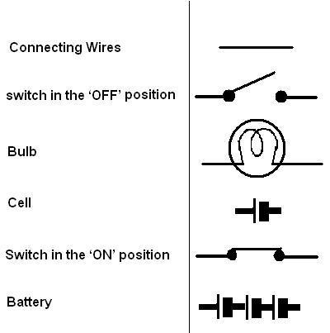

Q.2- Draw the circuit diagram to represent the circuit shown in Fig. 14.21.
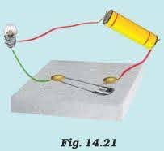

Ans.2-
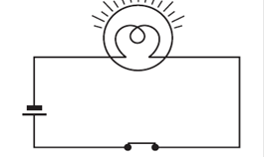

Q.3- Fig. 14.22 shows four cells fixed on a board. Draw lines to indicate how you will connect their terminals with wires to make a battery of four cells.
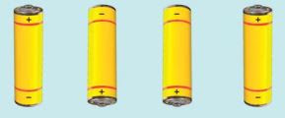

Ans.3-
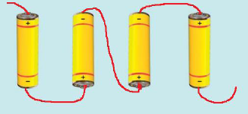

Q.4:- The bulb in the circuit shown in Fig. 14.23 does not glow. Can you identify the problem? Make necessary changes in the circuit to make the bulb glow.
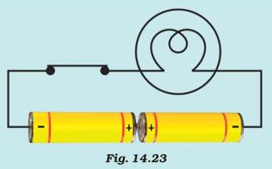

Ans.4- In this circuit, the positive terminal is connect to the positive terminal but always the positive terminal connects to the negative terminal. So, the circuit is not complete and the bulb is not illuminating.
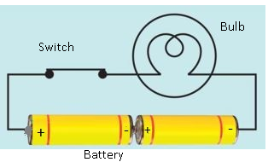

Q.5- Name any two effects of electric current.

Ans.5- The followings are two effects of electricity current are:-
- Magnetic Effect.
- Heating Effect.

Q.6:- When the current is switched on through a wire, a compass needle kept nearby gets deflected from its north-south position. Explain.

Ans.6- Because an electric wire creates a magnetic field around it. So a compass needle deflect from its north – south position, when compass kept nearby electric wire.

Q.7:- Will the compass needle show deflection when the switch in the circuit shown by Fig. 14.24 is closed?
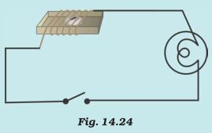

Ans.7:- No, Because there are not any electric source for switch electric current.

Q.8:- Fill in the blanks:-
a. Longer line in the symbol for cell represents its ____ terminal.
b. The combination of two more cells is called a ____.
c. When current is switched ‘on’ in a room heater, it ____.
d. The safety device based on the heating effect of electric current is called a ____.

Ans.8:-
a. Longer line in the symbol for cell represents its __positive__ terminal.
b. The combination of two more cells is called a __battery__.
c. When current is switched ‘on’ in a room heater, it __become hot__.
d. The safety device based on the heating effect of electric current is called a __fuse__.

Q.9:- Mark ‘T’ if the statement is true and ‘F’ if it is false:-
a. To make a battery of two cells, the negative terminal of one cell is connected to the negative terminal of the other cell. (T/F)
b. When the electric current through the fuse exceeds a certain limit, the fuse wire melts and breaks. (T/F)
c. An electromagnet does not attract a piece of iron. (T/F)
d. An electric bell has an electromagnet. (T/F)

Ans.9:-
a. False.
b. True.
c. False.
d. True.

Q.10:- Do you think an electromagnet can be used for separating plastic bags from a garbage heap? Explain.

Ans.10- No, because electromagnet attract only with the magnetic things like iron and steel. Hence magnet cannot be used to separate plastic bags.

Q.11- An Electrician is carrying out some repairs in your house. He wants to replace a fuse by a piece of wire. Would you agree? Give reasons for your responsible.

Ans.11- No, this is a worst idea to replace fuse as a piece of wire. In case of metal piece, melting point will be high and the circuit will be intact in case there is overload or overheat.

Q.12- Zubeda made an electric circuit using a cell holder shown in fig. 14.4, a switch and a bulb. When she put the switch in the ‘ON’ position, the bulb did not glow. Help Zubeda in identifying possible defects in the circuit.

Ans.12- The following possible reason defects in the circuit are:-
i. The Connection wire loose or unconnected.
ii. May be bulb are fuse.
iii. May be cells are run out.

Q.13- In the circuit shown in fig. 14.25
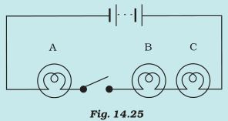
i. Would any of the bulb glow when the switch is in the ‘OFF’ position?
ii. What will be the order in which the bulbs A, B and C will glow when the switch is moved to the ‘ON position’?

Ans.13-
i. No, the bulb will not glow as the circuit is not complete when the switch in ‘OFF’ position.
ii. All bulbs are glow when switch is in ‘ON’ Position.

